7.65: a) The magnitude of the work done by friction is the kinetic energy of the package at point B, or 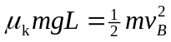, or
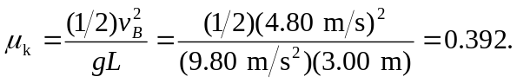

b)
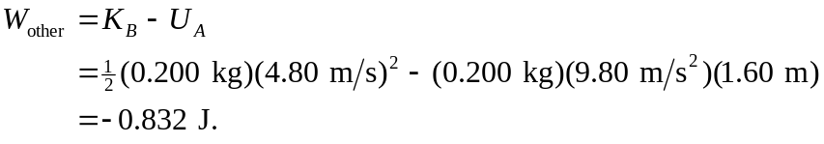

Equivalently, since 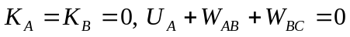, or

